Sheet 1- Assignment 2

- Environment Setup
  - 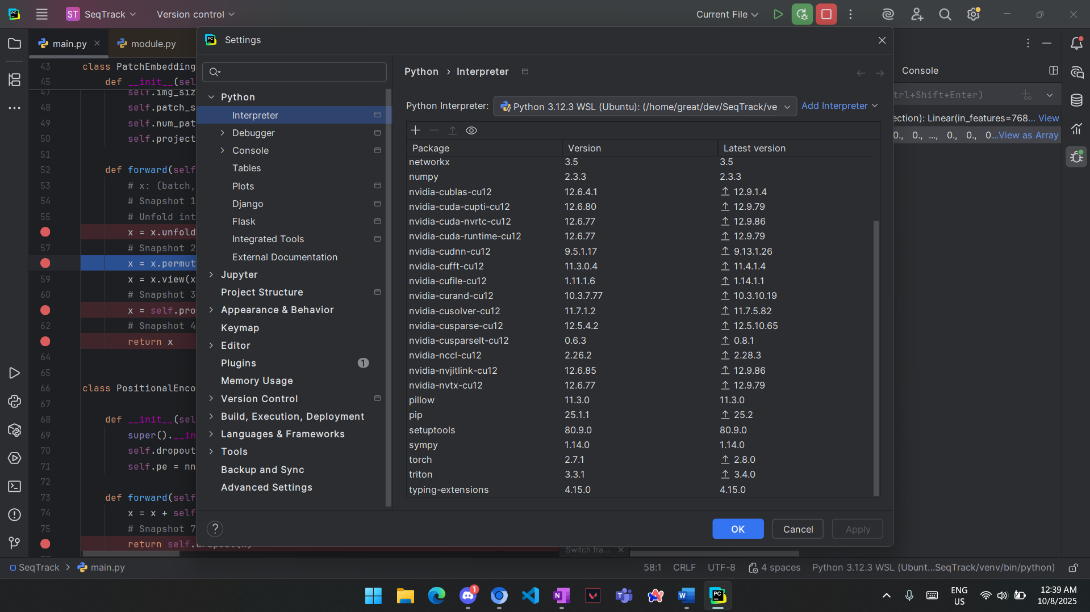
- Used Image:
  - 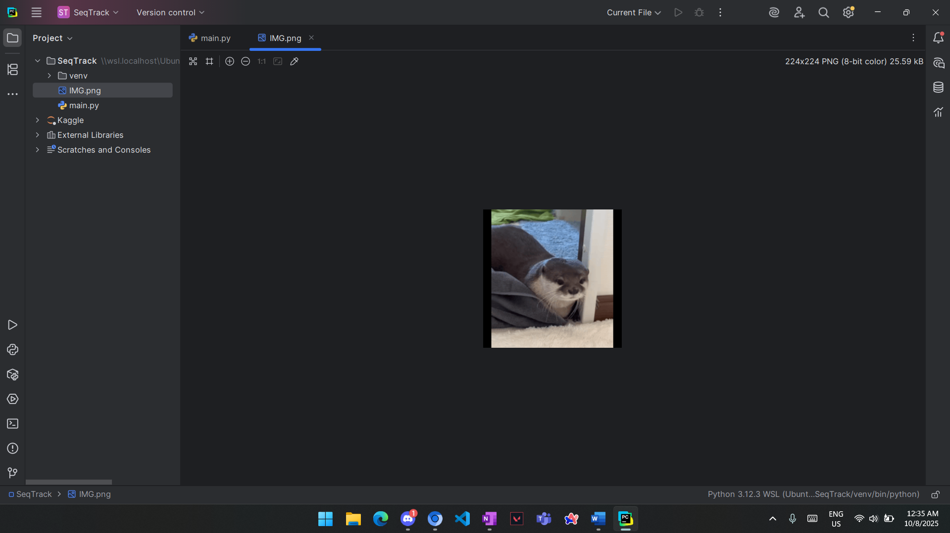

- Snapshots:
  - Snapshot 1 (Raw input image after preprocessing (changed to RGB)):
    - 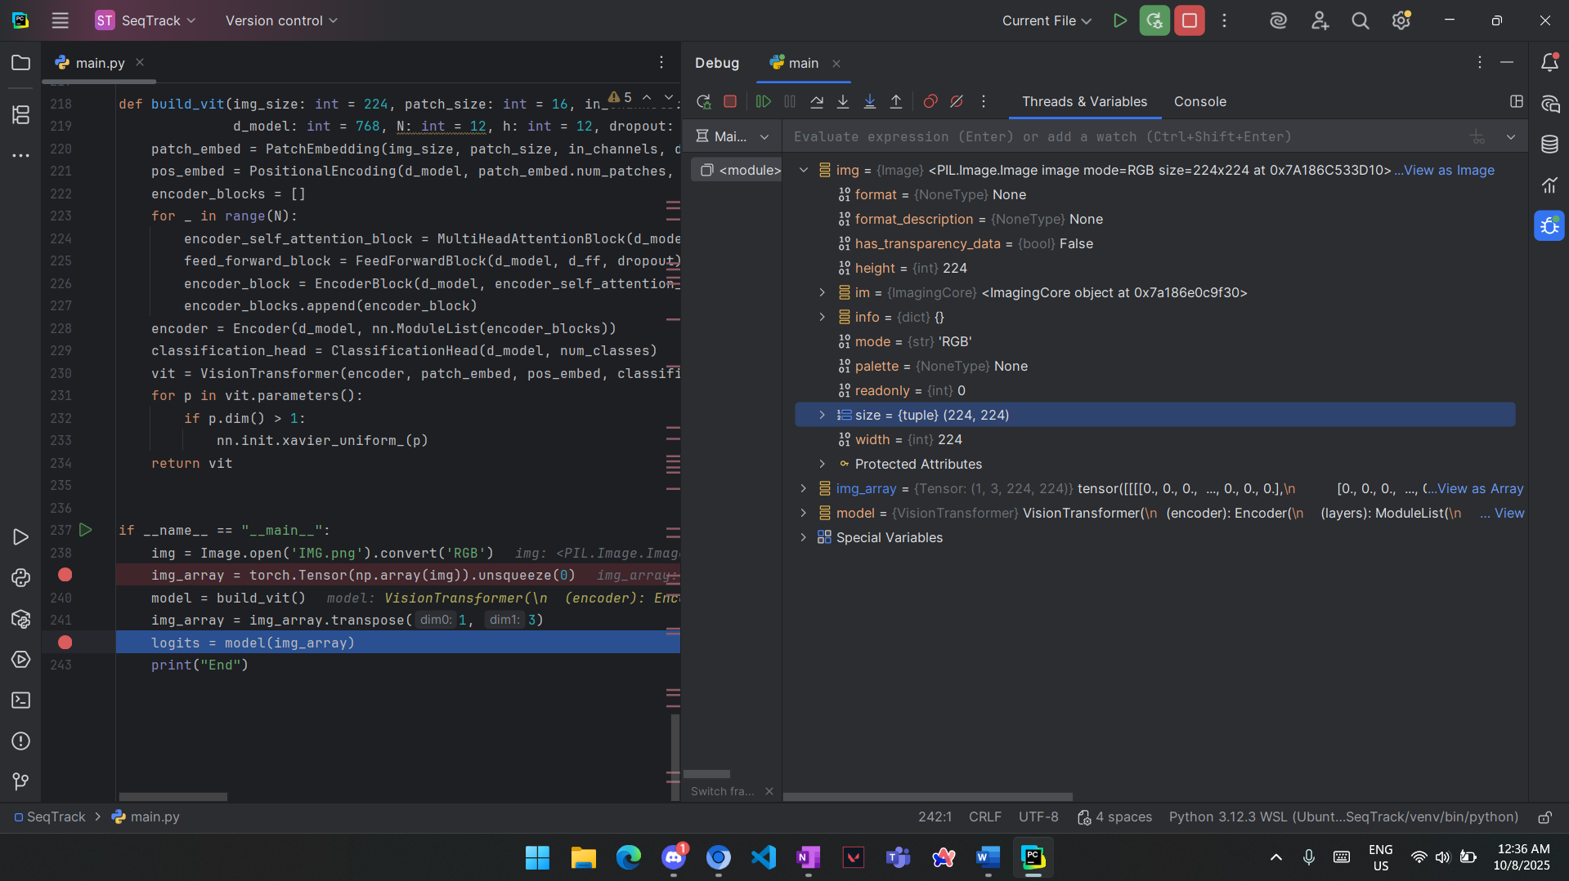

    - Shape (1,3,224,224) which means one image which is RGB each color channel have 224*224 pixels
  - Snapshot 2 (Image divided into patches (before flattening))
    - 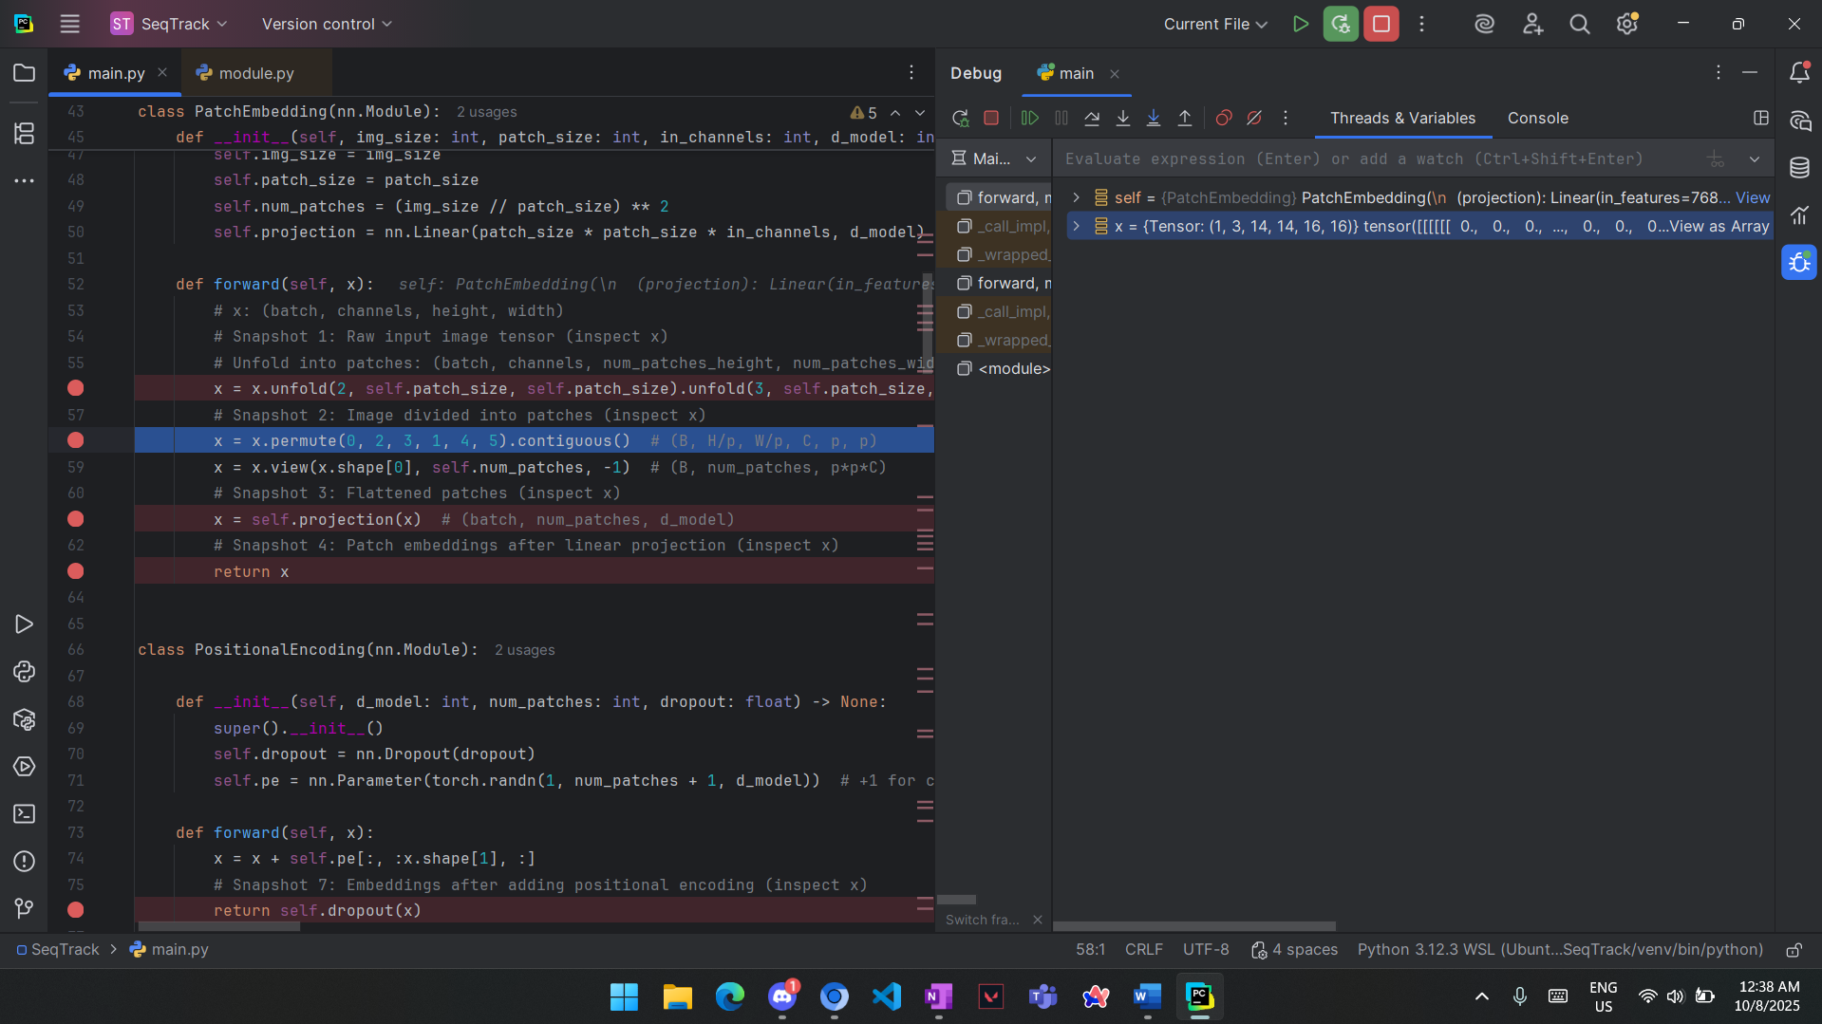

    - The shape is (1,3,14,14,16,16) as the image is divided into small equal images which are 14 small image in each row and 14 small images columns (14*14) each image of size (16*16) and we split the image because Transformers operate on sequences of tokens
  - Snapshot 3 (Flattened patches (reshaped into vectors))
    - 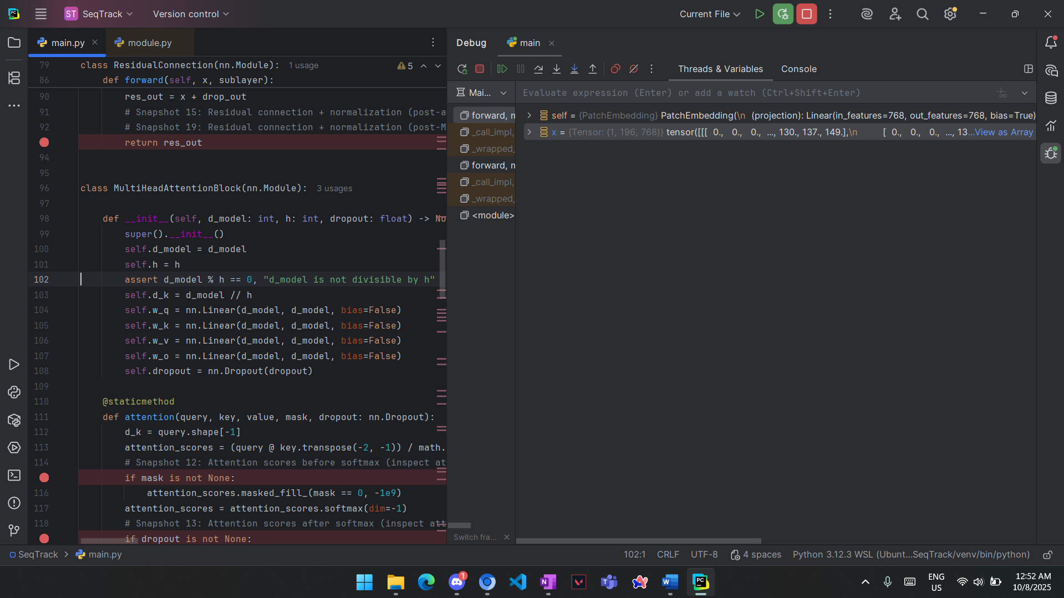

    - Shape (1,196,768) which means one image splitted into 196 patch each patch have 768 pixel (feature)
  - Snapshot 4 (Patch embeddings after linear projection)
    - 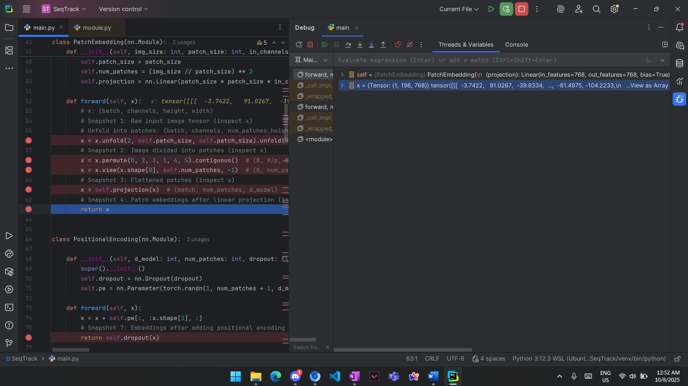

    - Same shape (1,196,768) but the values changed due to the linear projection

  - Snapshot 5&6 (class token before concat, embeddings after adding the class token
    - 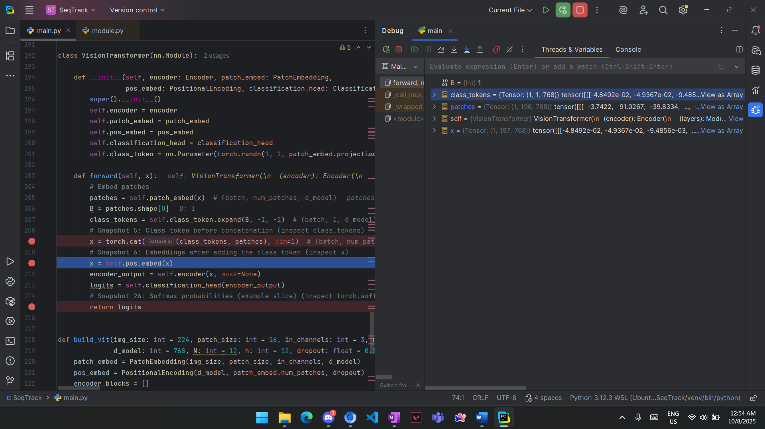

    - Class token shape (1,1,768) class token for 1 image and it contains 768 (same number of pixels in each patch) so it capture the important features from the image
    - Embeddings after adding class token shape is (1,197,768) the number of patches increased by 1 cause it now have additional patch which class token

  - Snapshot 7&8 (Embeddings after adding positional encoding & encoder block input tensors)
    - 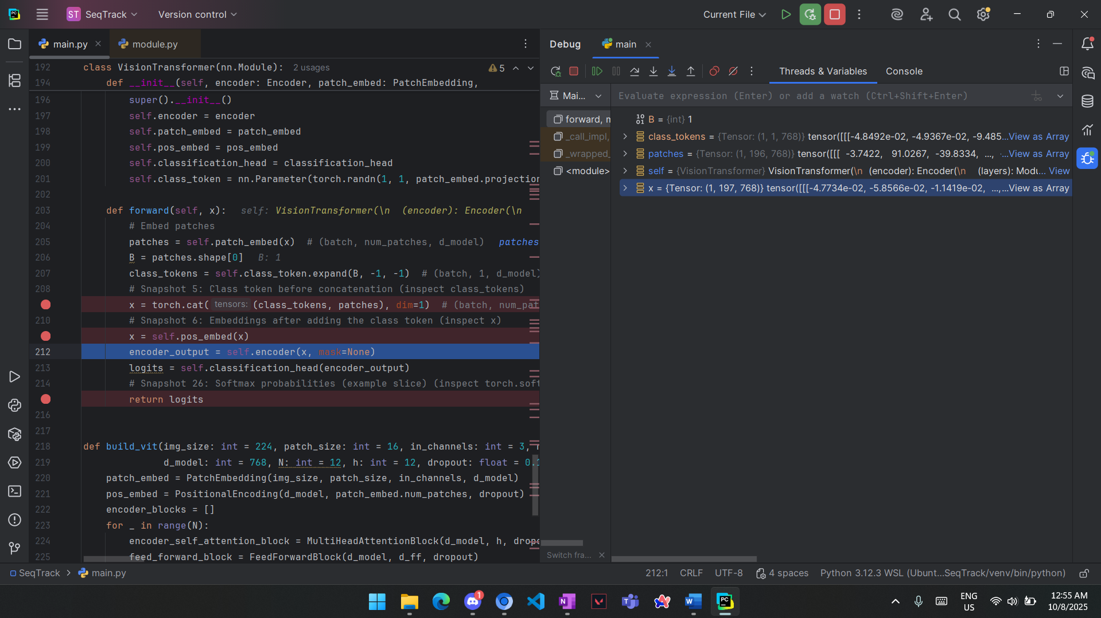

    - Embeddings after adding positional encoding is encoder block input tensors which has the same shape as before (1,197,768) but the values are changed cause of adding the positional encoding which is needed to know the position of each patch (e.g. upper right corner, upper left corner, etc.)
  - Snapshot 9&10&11 (Multihead attention q,k,v)
    - 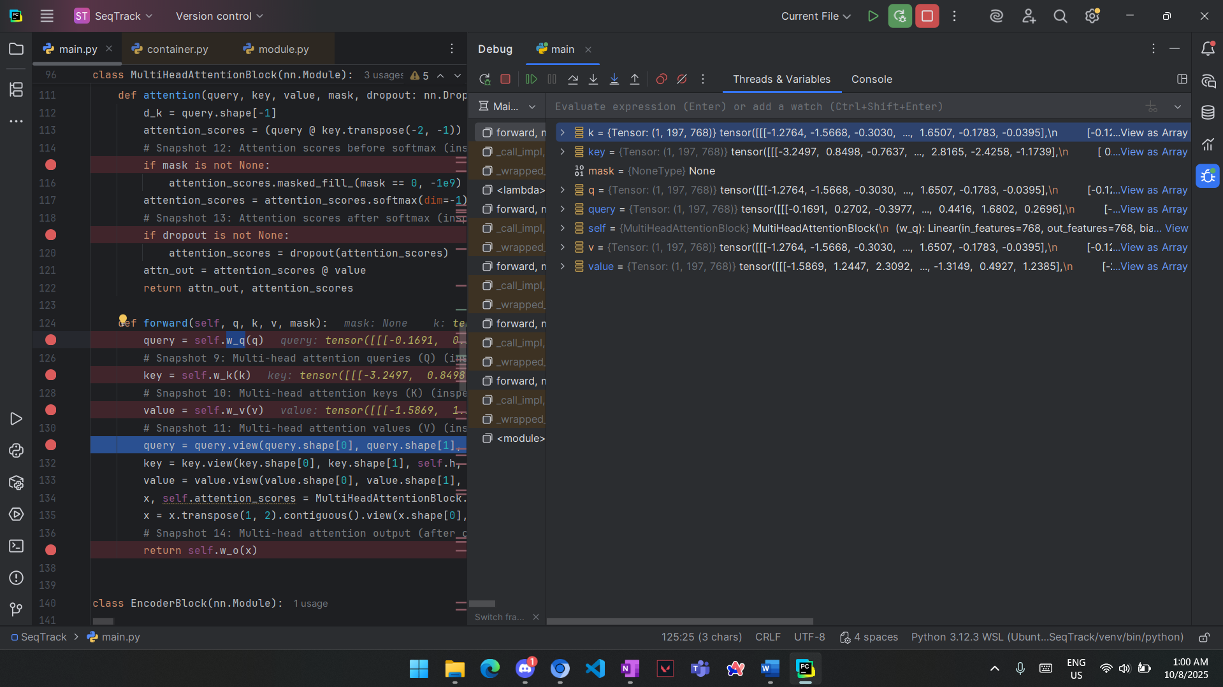

    - q,k,v are all of the same shape as the embeddings (3 copies of it) (1,197,768)
  - Snapshot 12 (attention scores before softmax)
    - 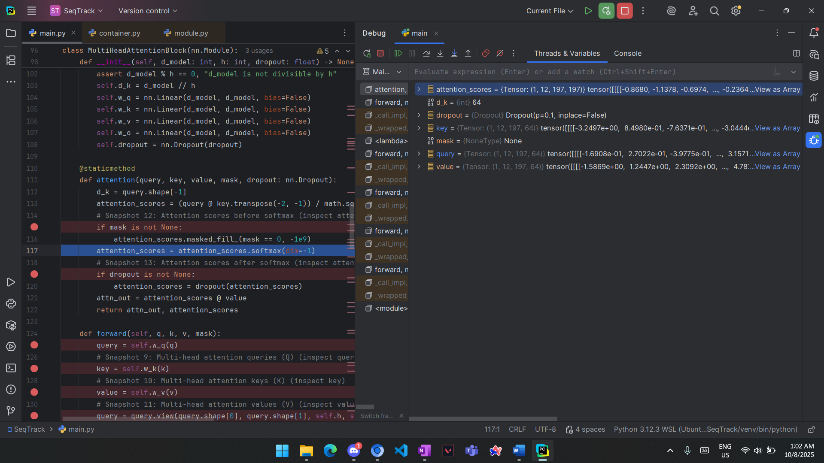

    - Attention scores contains negative values (softmax is not applied) and it’s shape is (1,12,197,197) as we have 12 heads each contains the relation of each patch to the other patch (197*197).

  - Snapshot 13 (attention scores after softmax)
    - 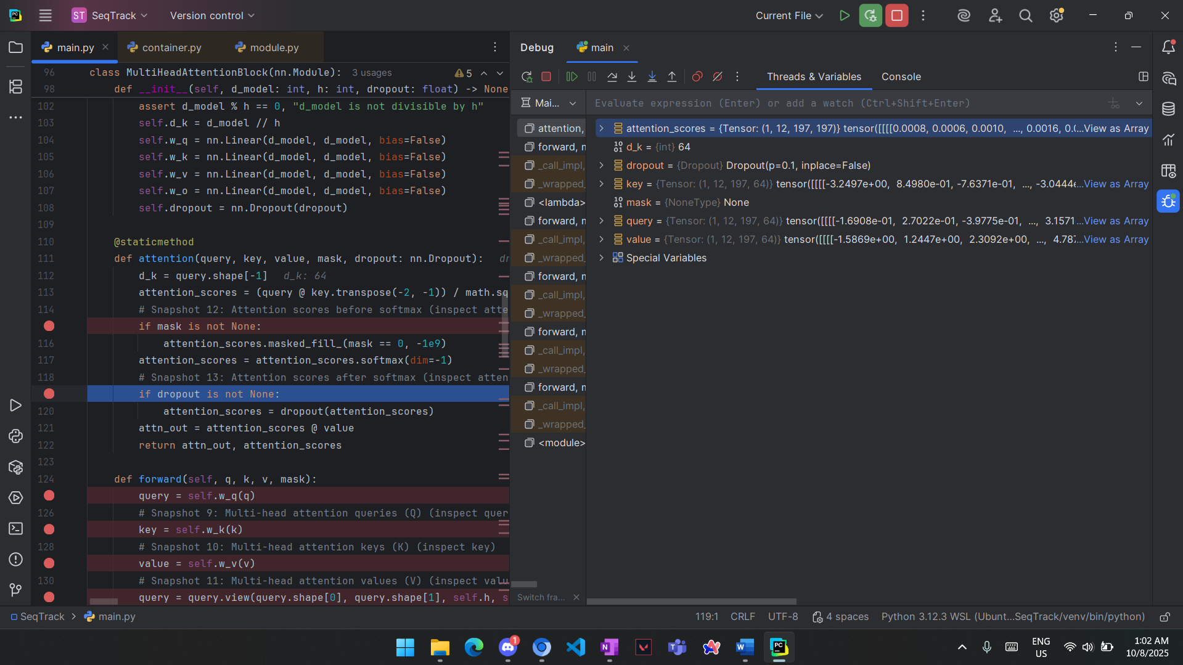

    - Same shape as the previous snapshot but the values are different (no negative values) as the softmax is applied.
  - Snapshot 14 (multihead output after concat.)
    - 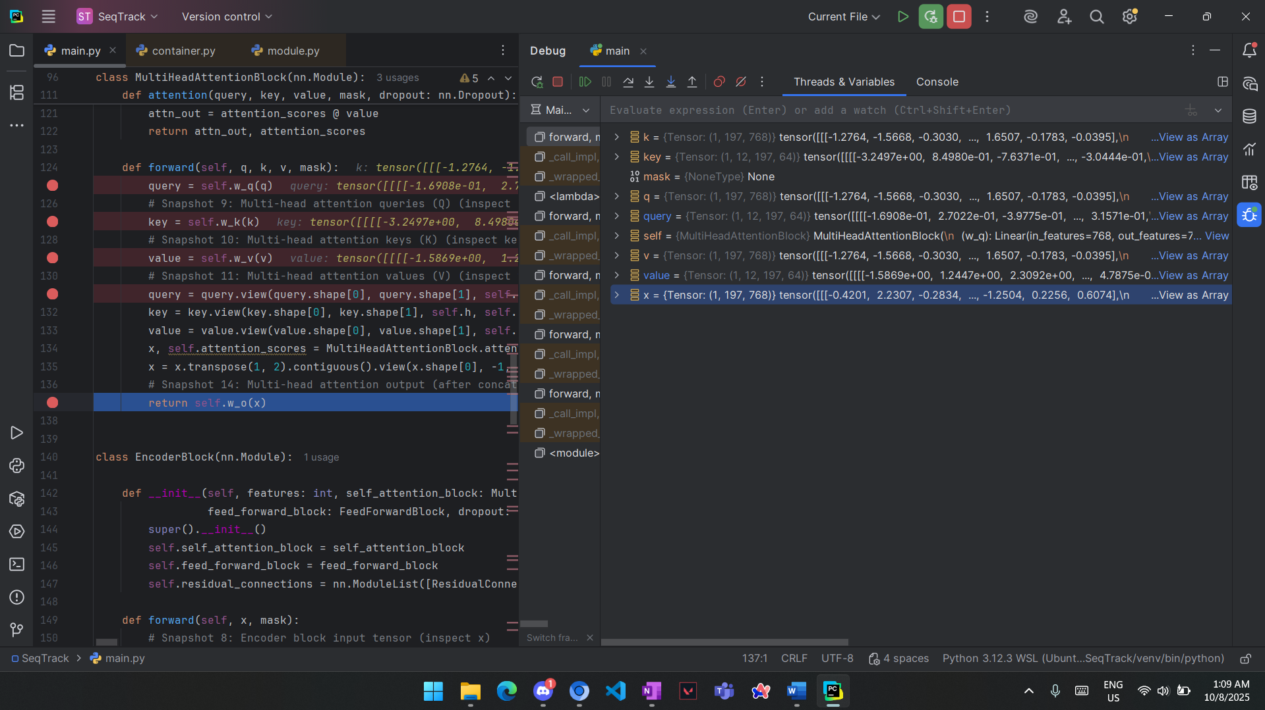

    - after concatenation the shape returned to (1,197,768) which is 1 image having 196 patch and class token each of them contains 768 feature
  - Snapshot 15 (Residual connection + normalization (post-attention))
    - 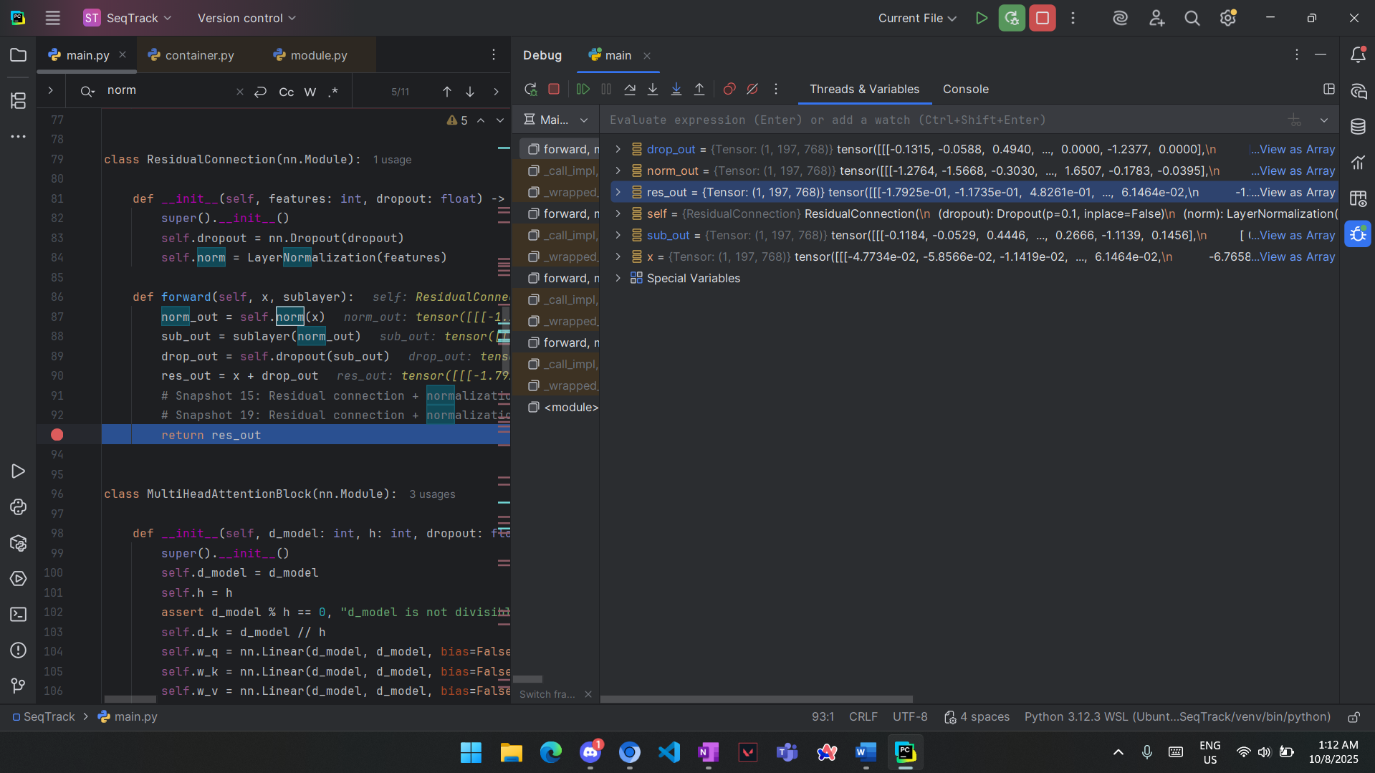

    - Same shape as before (1,197,768) as we only did matrix summation of 2 matrices of the same shape.

  - Snapshot 16&17&18 (Feedforward input, Feedforward first hidden layer output, Feedforward second hidden layer output)
    - 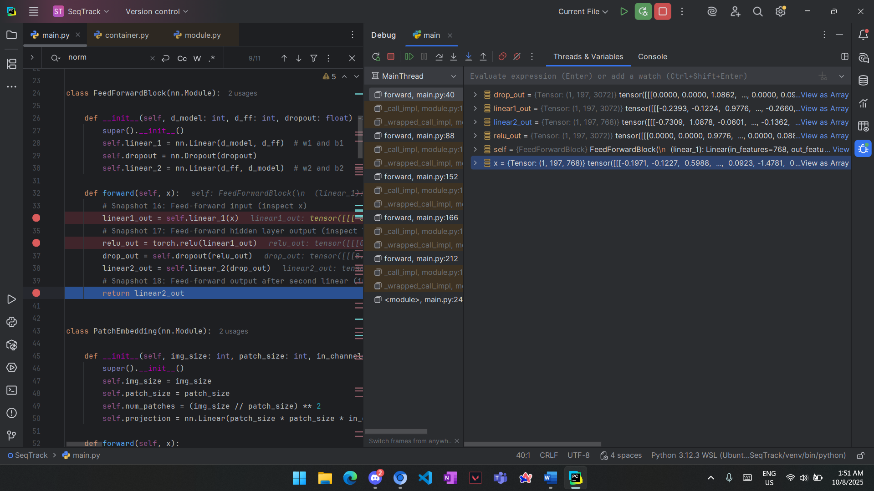

    - “X” is the feedforward input with the same shape as the previous snapshot
    - “Linear1_out” is of shape (1,197,3072) as it project the 768 feature to 3072 to capture more information.
    - “Linear2_out” is of shape (1,197,768) as it return it to the same shape of the input to maintain the same shape across the all the model layers.
  - Snapshot 19&20 (Residual connection + normalization (post-MLP), Encoder block final output)
    - 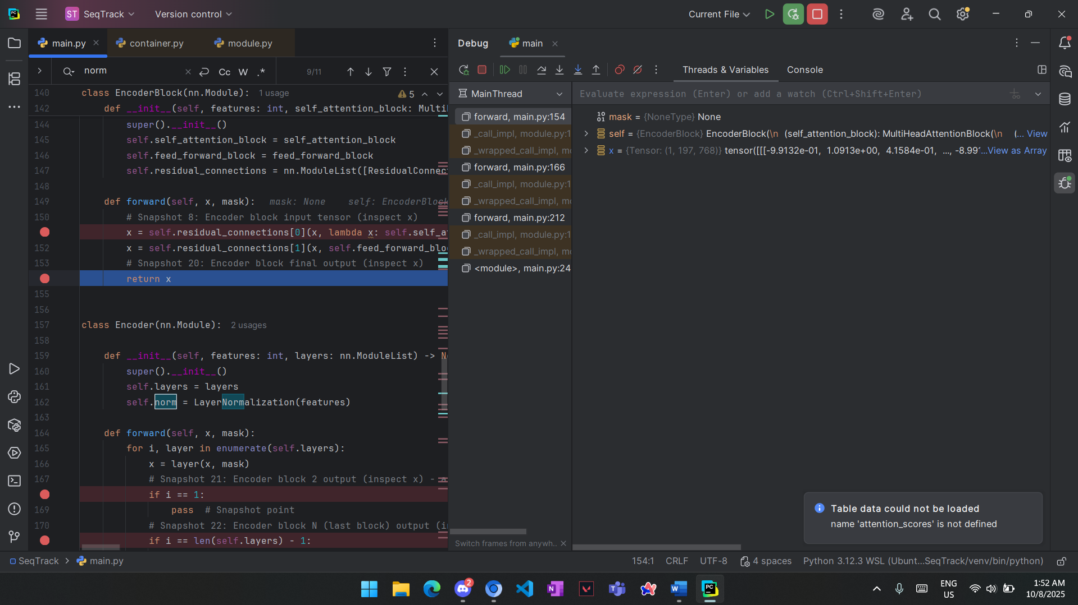

    - “X” here is the encoder block output and it is the same as the second residual connection output with shape (1,197,768) as the residual connection just do matrix summation

  - Snapshot 21&22&23 (Encoder block 2 output, last encoder block output, Final sequence output (including class token))
    - 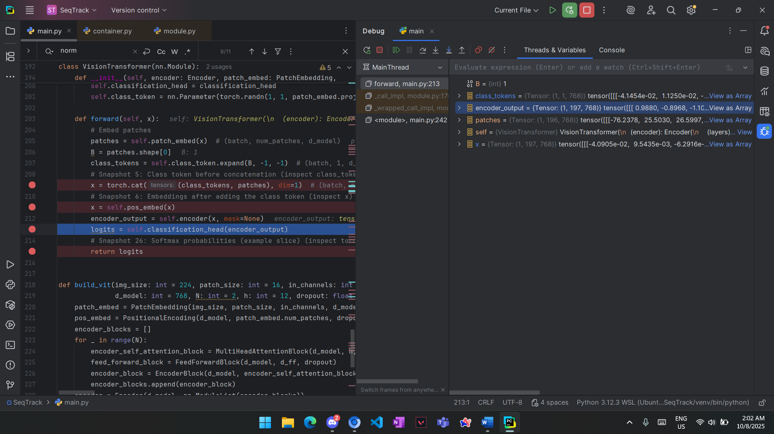

    - In our implementation we had only 2 encoder blocks so the encoder block 2 output is the same as the last encoder block output which is the same as Final sequence output and it has the same shape as before (1,197,768) but the values are different.
  - Snapshot 24 (Class token extracted (final representation))
    - 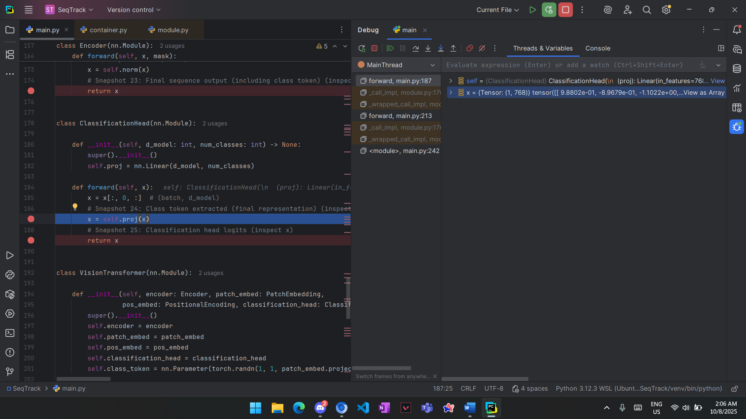

    - The shape is (1,768) as now we extracted class token features only and we use it only for classification as it gather global information and to keep the classifier simple.

  - Snapshot 25 (Classification head logits)
    - 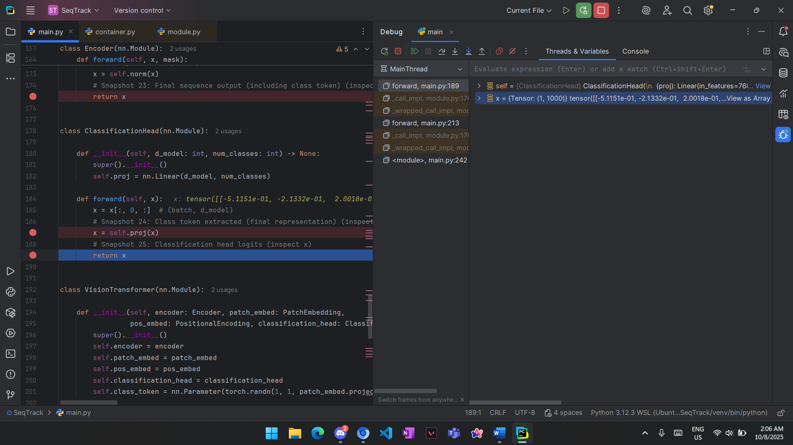

    - Now the shape is (1,1000) as we projected the class token to 1000 through the final mlp as we have 1000 class

  - Snapshot 26 (Softmax probabilities (example slice))
    - 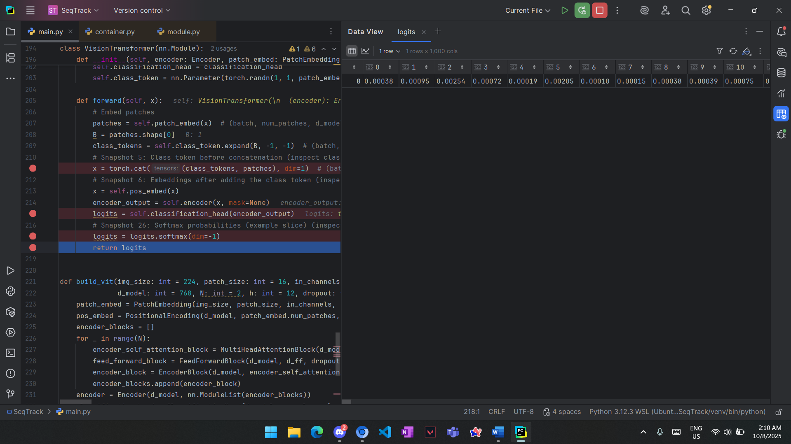
    - The same shape as the previous snapshot but the values are different (no negative values) as we applied softmax so each value is the probability of each class

